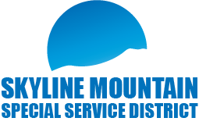
SMSSD Public Budget Hearing
and Board Meeting
December 22, 2025
6pm to 8:30pm
Senior Citizens Center
101 East 100 North Mt. Pleasant. Utah 84647
Public Budget Hearing
- Proposed Final 2025 Budget
- Proposed 2026 Budget
Board Meeting
- Approval of last meeting minutes
- Approval of financials
- 2024 Full Audit
- Resolution 2025-01 Data Privicy
- Update on water system
- Report from SMSSD/SMR Liaison
- New / Old Business
- Open time for customers on agenda
- Adjourn
- Executive Meeting
- Adjourn
Join Zoom Meeting:
https://us06web.zoom.us/j/4287678058?pwd=TWxSbVR1NWFhTG9vNE0zVklZenBhdz09&amp;omn=88648414810
One-tap mobile: +12532158782,,4287678058#,,,,*366822#
Meeting ID: 428 767 8058

